Operating Manual
NATIONGATE SOLUTION (M) SDN BHD
AutoGRN Program

PREPARED BY BIZSMART TECHNOLOGY SDN BHD
UPDATED: 14/7/2023
Contents
Start Program 3
AutoGRN Process 4
Register New Vendor 10
Edit Existing Vendor 13
Error Cases 15
Error When Unable to Get Code 15
Error When GRN Barcode Not Verified 16

Start Program
- On all the power.
- Turn on the CPU.
- After Desktop is loaded, double Click “AutoGRN Conveyor”.
- The program is opened.
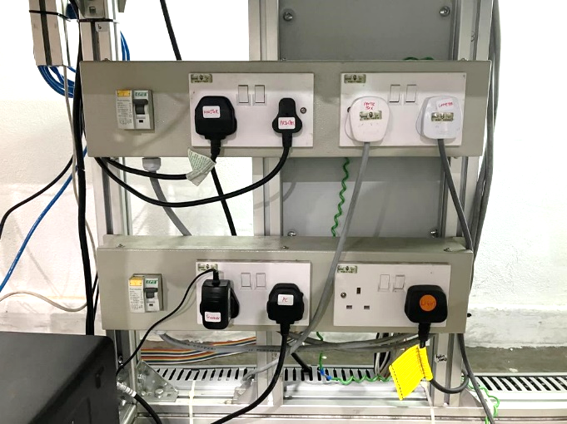
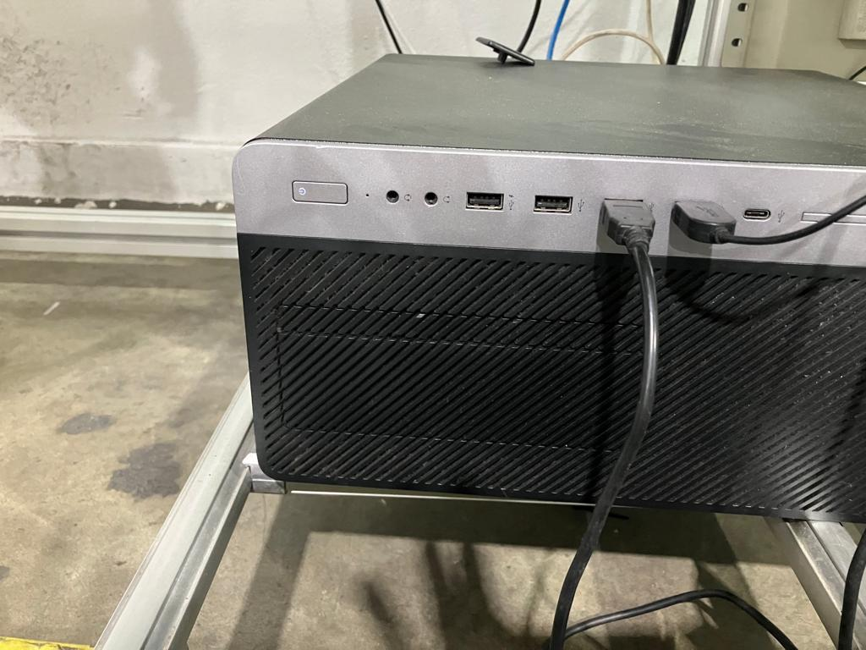

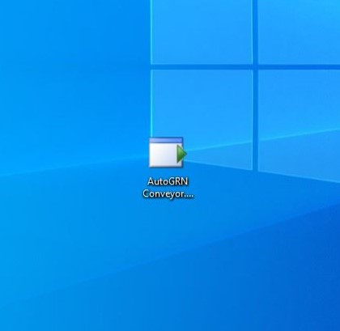
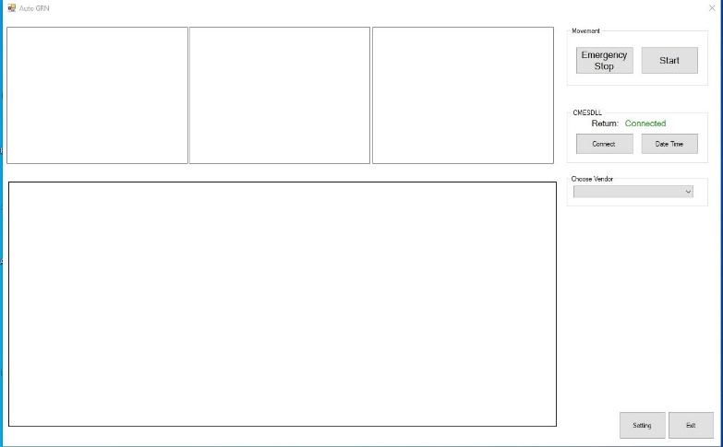

AutoGRN Process
- Make Sure CMESDLL is connected. Press “Connect” button and try to connect if it is not connected.
- Choose the vendor that was registered.
- Press “Start” Button.
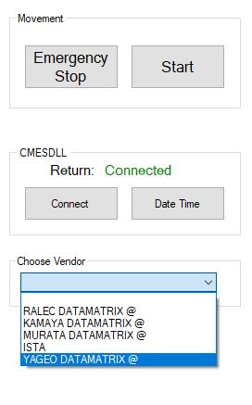
2
1
3

- Place the reel on conveyor belt according to the markings. 2D Barcode need to be top and bottom of the reel.

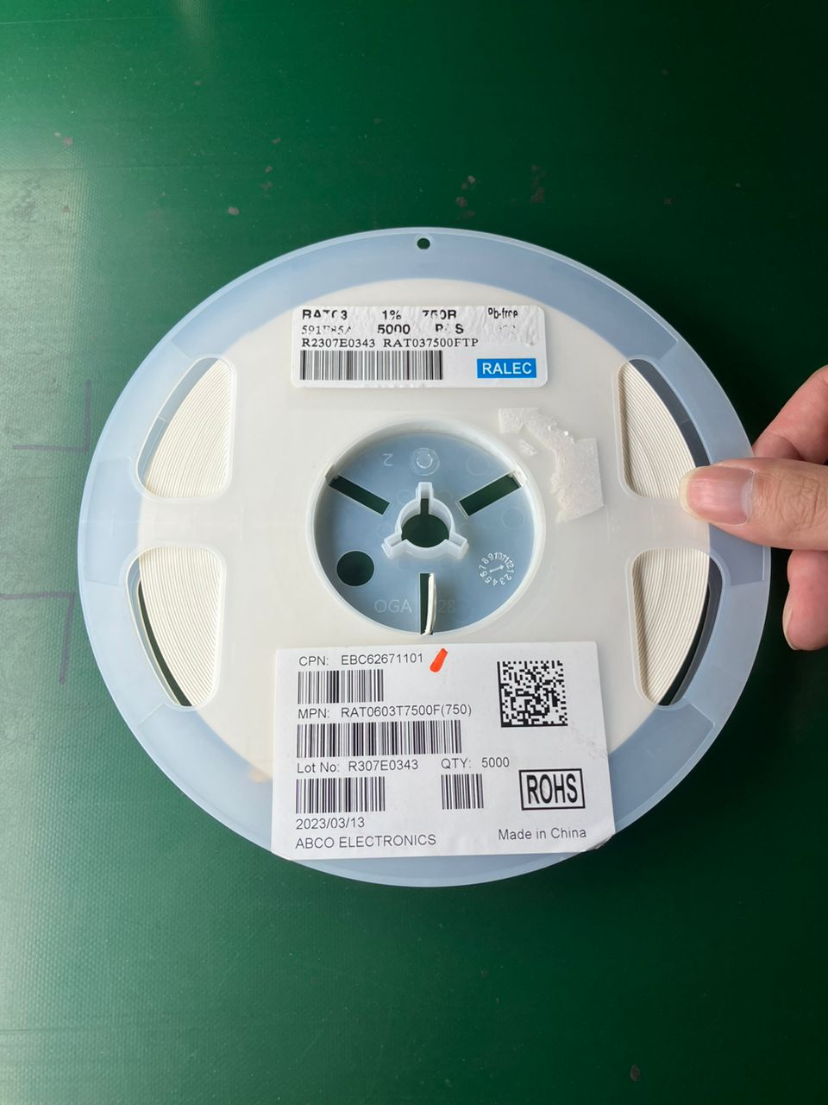
CONVEYOR MOVING DIRECTION
2D Barcode is on top or bottom.


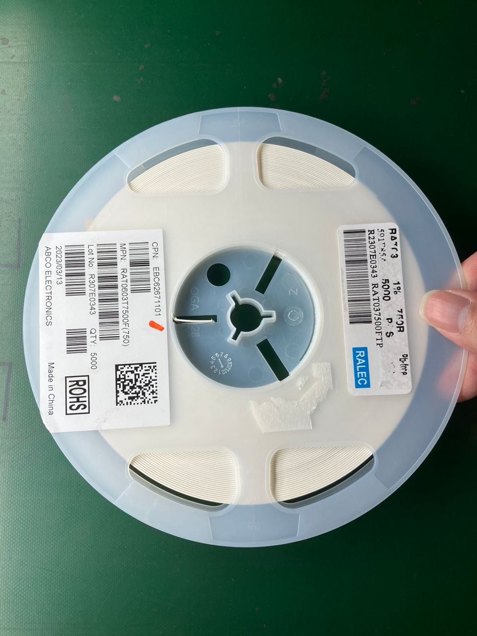
2D Barcode is on left or right.
CONVEYOR MOVING DIRECTION

- Camera will capture and decode reel information when the reel passes through.
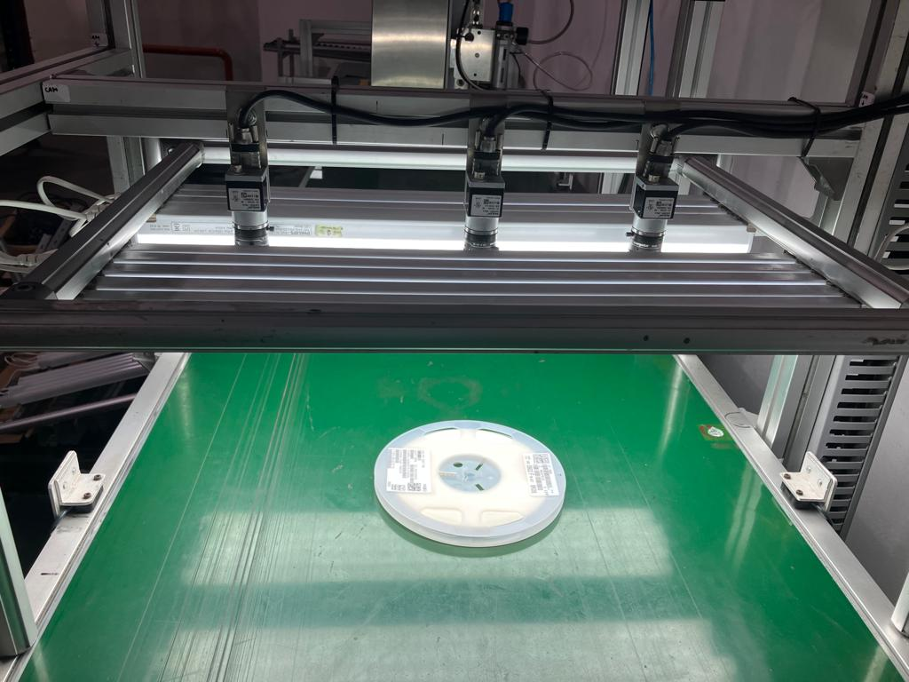
- The decoded reel information is displayed on the program.
- Reel information is sent to the ERP system, and ERP return is displayed.
- A print job that consists of ERP return information is sent to printer, with the sending status displayed.
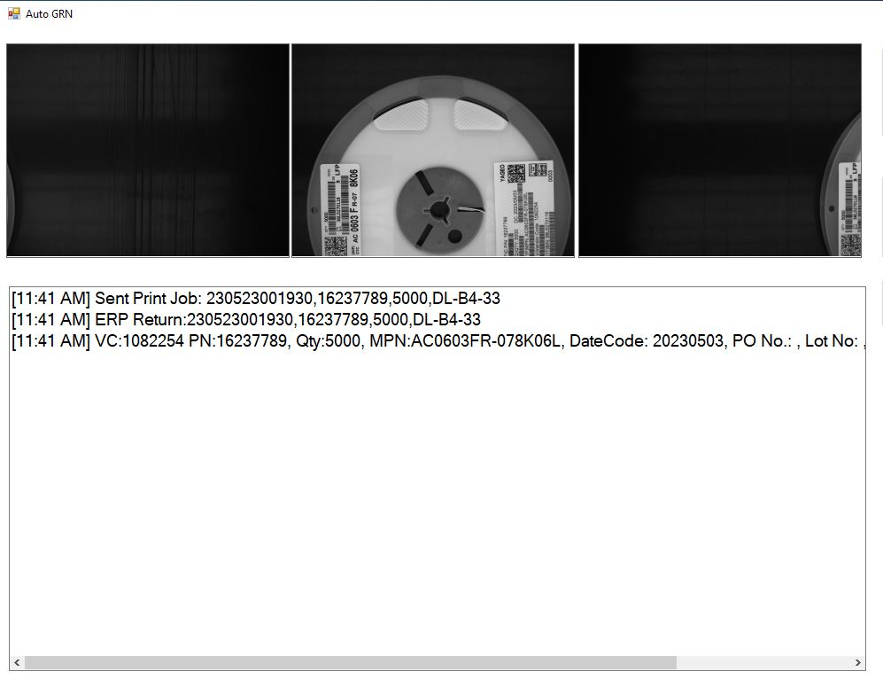
- When reel arrives printer, printer will stamp the sticker with information containing ERP Return value.
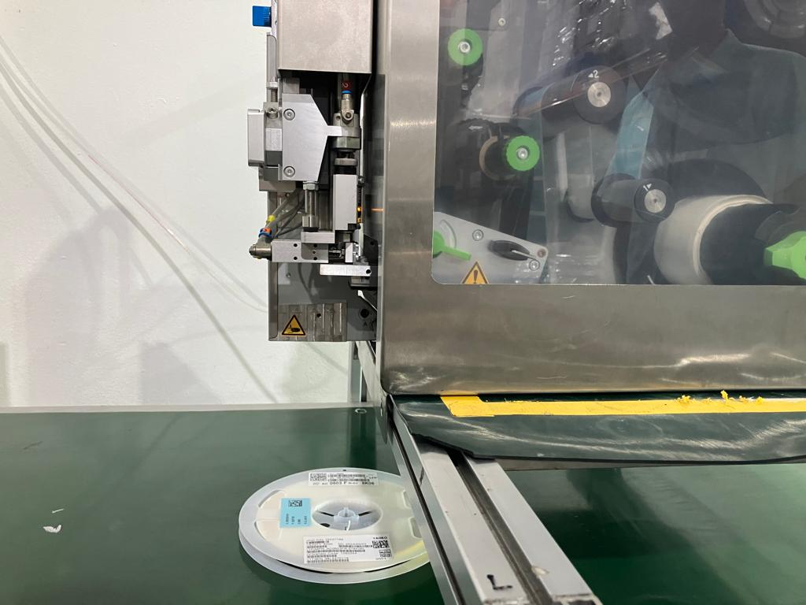
- Barcode Scanner at the end on conveyor will verify the data matrix on the stamped sticker.
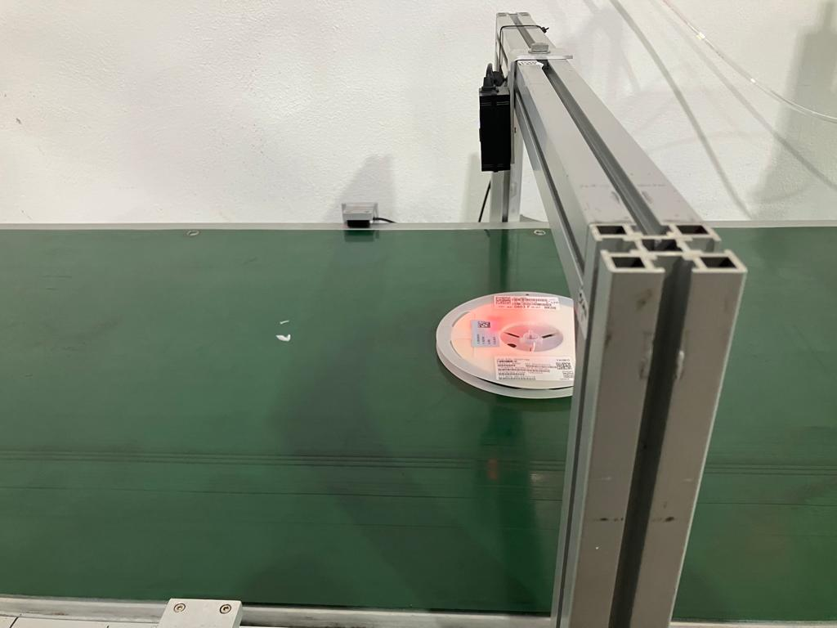
- Program will display the verified data matrix on screen.
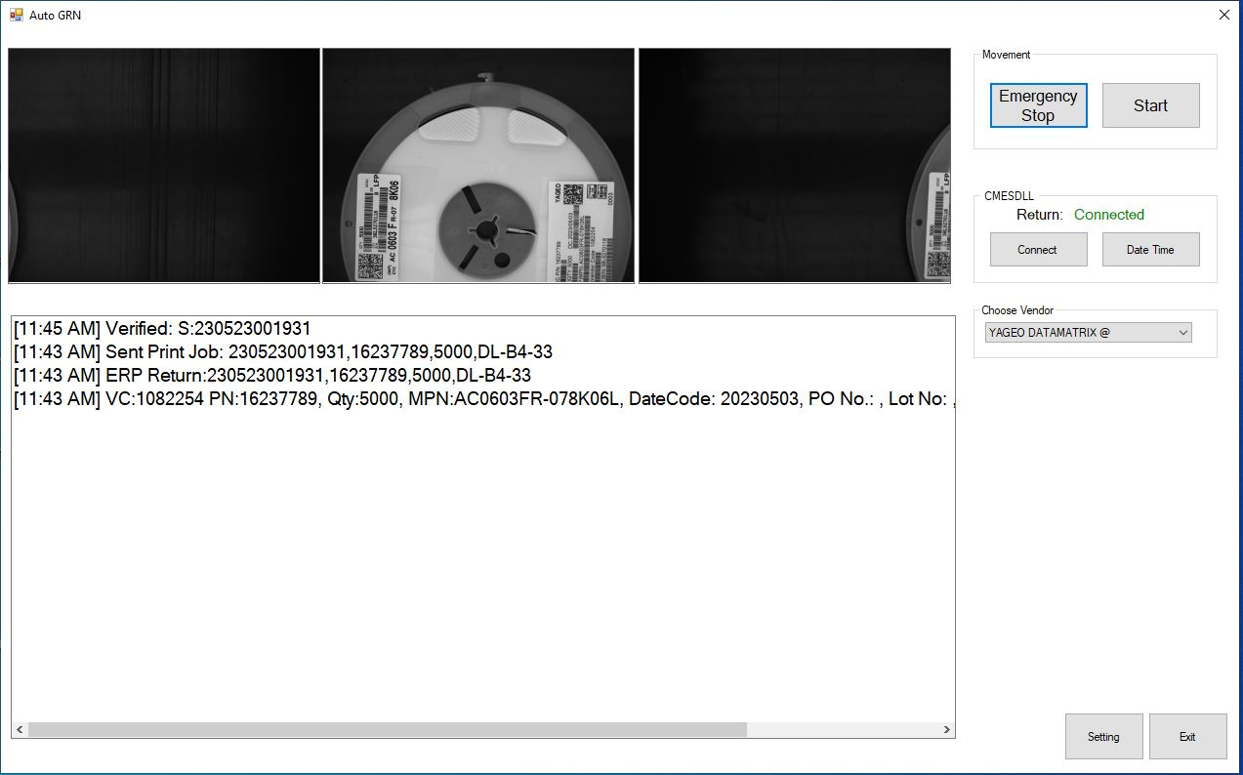

Register New Vendor
- Click “Settings” on the home page.
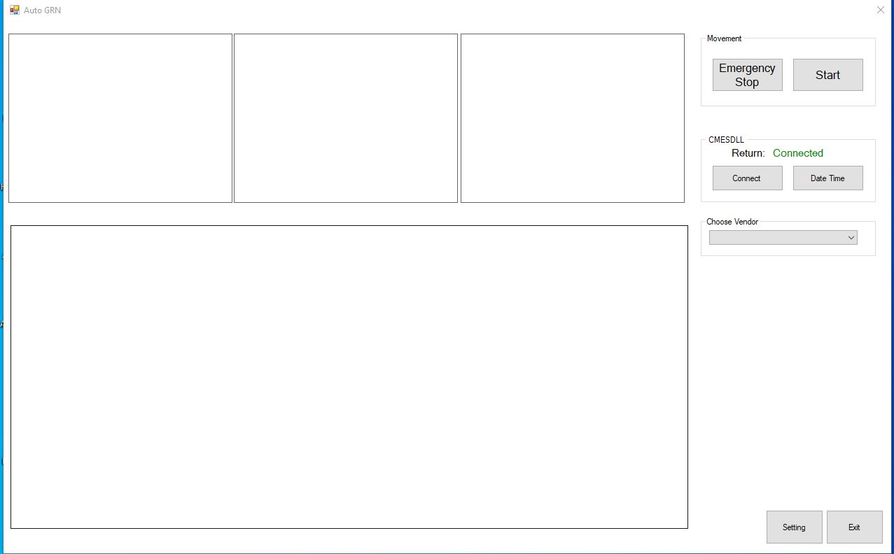

- In setting page, click “Register”.
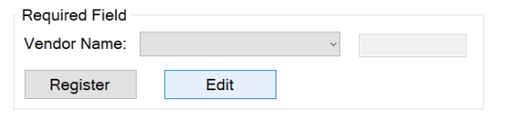

- The Registration Form is shown:
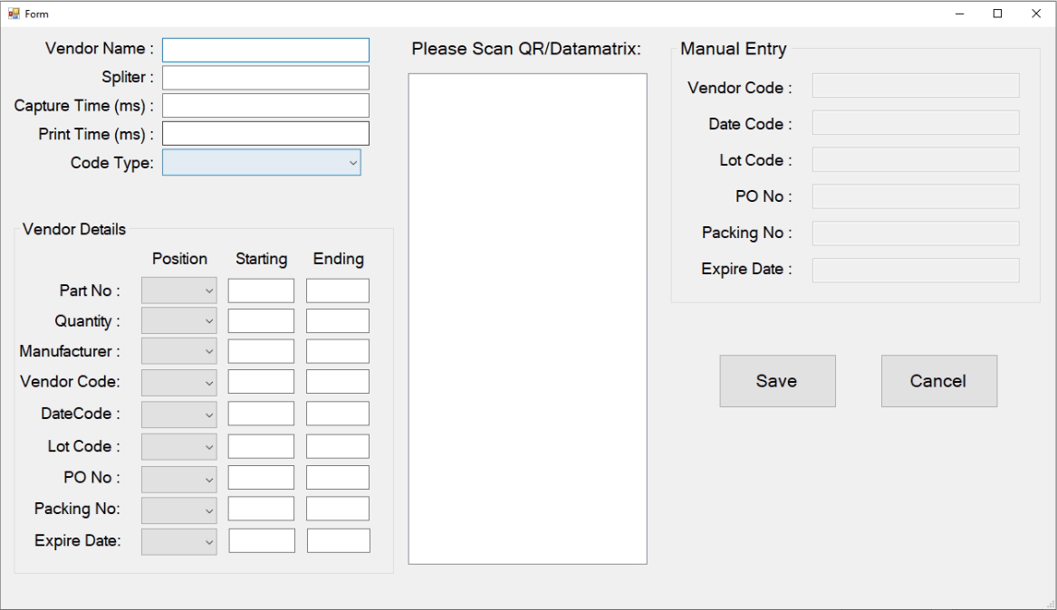

- Scan the reel’s Datamatrix or QR using the barcode scanner.
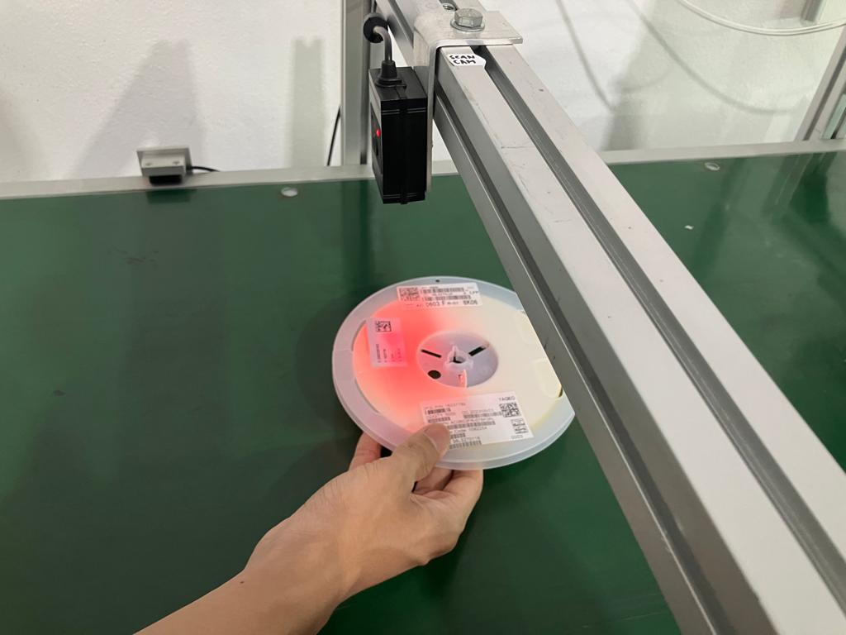
- Vendor Name – Fill in suitable vendor name. Vendor name cannot be duplicate.
- Splitter – Splitter is auto detected after scanning QR/Datamatrix. Do not modify the field, if info is shown on the right successfully.
- Capture Time – The delay time for camera to capture image.
- Print Time – The delay time for printer to stamp sticker.
- Code Type – Choose between Datamatrix and QR according to need.
- Vendor Details
  - Fill in “Position”, “Starting” and “Ending” accordingly, with the visualized information at the right box.
  - If the information does not exist, choose N/A, and fill in the information in “Manual Entry”.
  - Part Number, Quantity, Manufacturer and Vendor Code are mandatory fields.
- Click “Save”.
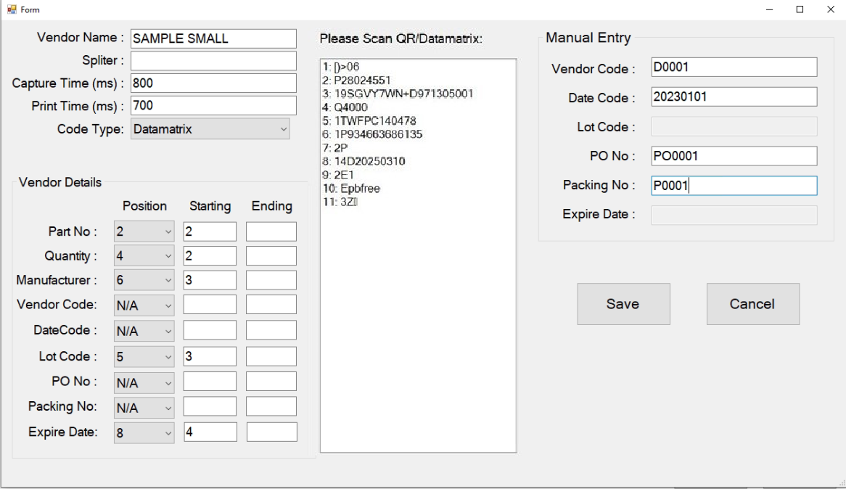

Edit Existing Vendor
- Click “Settings” on the home page.

- In setting page, choose vendor and click “Edit”.
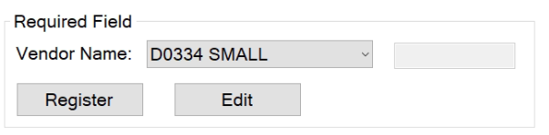

- The Edit Form is shown. Change the information according to needs. Click “Save”.
  - Vendor Name – Fill in suitable vendor name. Vendor name cannot be duplicate.
  - Splitter – Splitter is auto detected after scanning QR/Datamatrix. Do not modify the field, if info is shown on the right successfully.
  - Capture Time – The delay time for camera to capture image.
  - Print Time – The delay time for printer to stamp sticker.
  - Code Type – Choose between Datamatrix and QR according to need.
  - Vendor Details
    - Fill in “Position”, “Starting” and “Ending” accordingly, with the visualized information at the right box.
    - If the information does not exist, choose N/A, and fill in the information in “Manual Entry”.
    - Part Number, Quantity, Manufacturer and Vendor Code are mandatory fields.

Error Cases

Error When Unable to Get Code
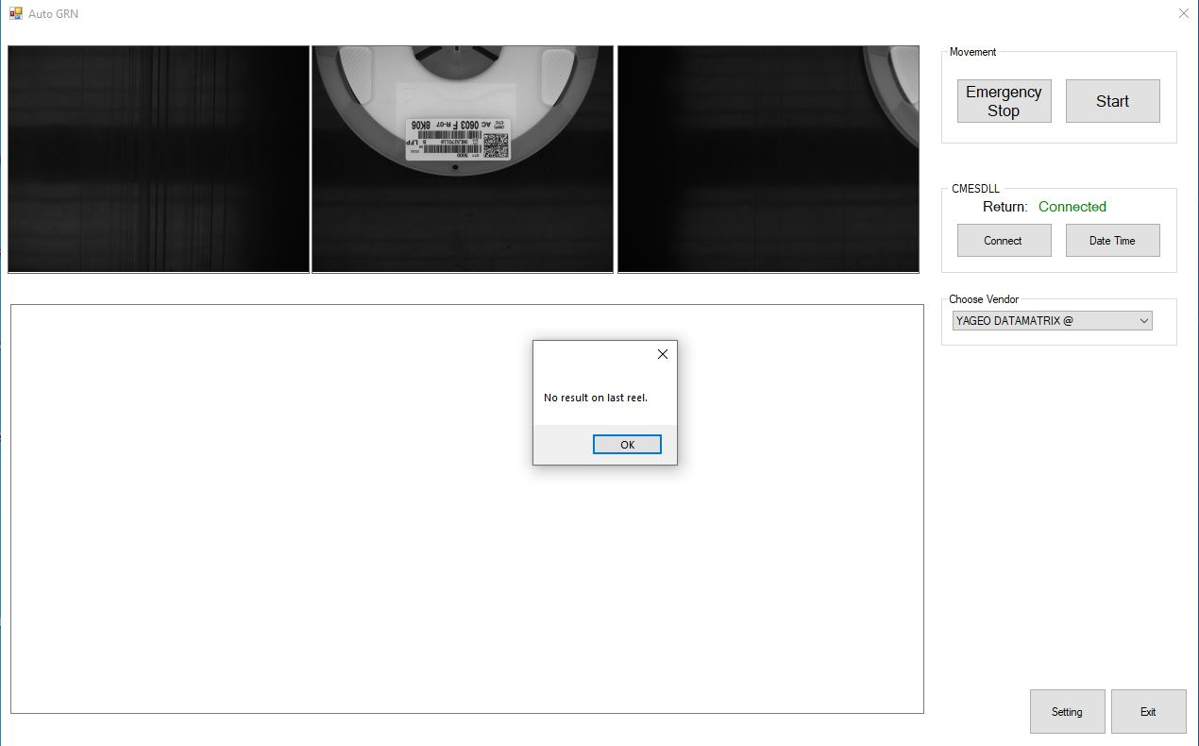
This is due to the target barcode is not in the capturing range.
- Click “OK”.
- Adjust the orientation of the reel.
- Edit the “Capture Time” in Settings.
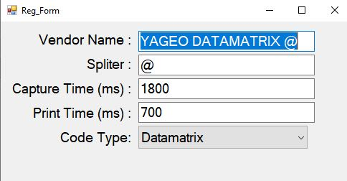
- Place the reel back at the start of conveyor.
- Click “Start” at homepage to continue.

Error When GRN Barcode Not Verified
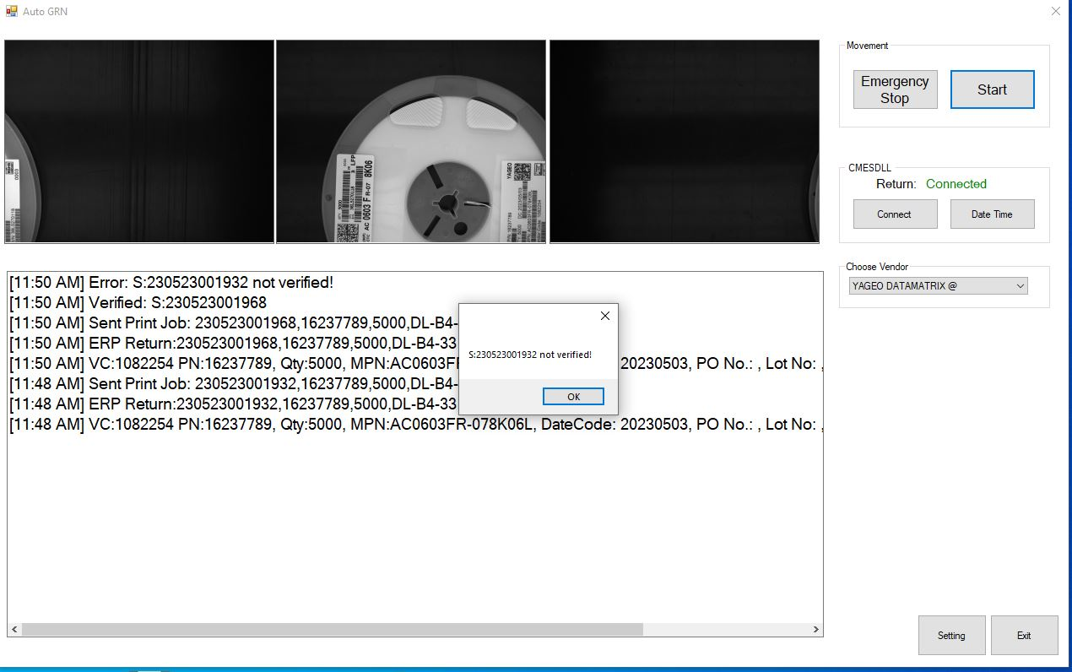
This is due to previous Barcode is not scanned.
- Click “OK”.
- Take the previous reel and scan its GRN barcode.
- Display will show that the GRN barcode is verified.
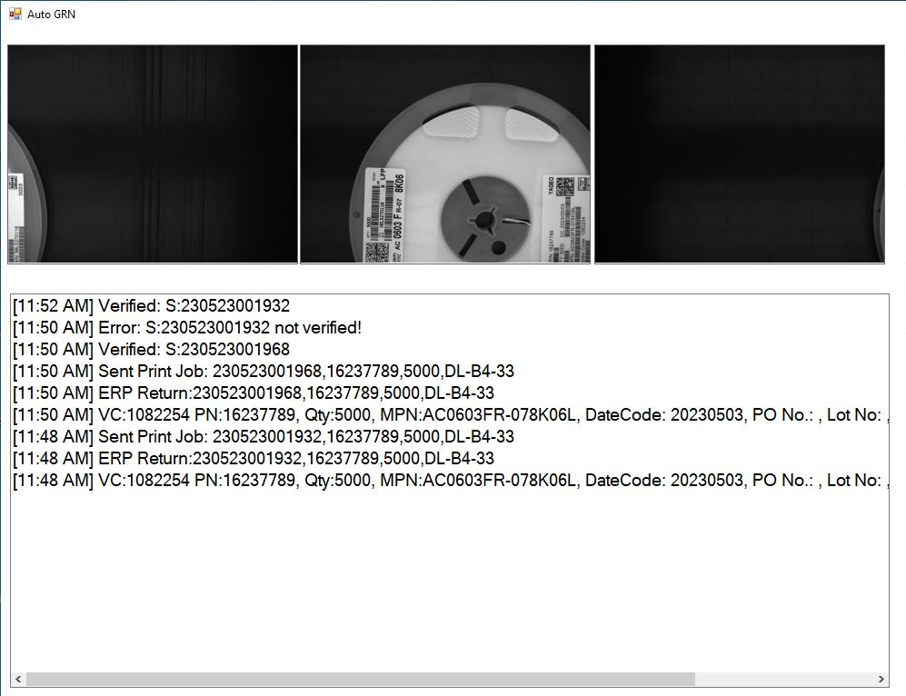
- Click “Start” at homepage to continue AutoGRN.

